Week 5 Resources:
If you are unable to print out the resources, you can do your activities and planning in your blank exercise book.

Choose a video from the Literacy Shed and write a story based on it.
If you need to, use the story map below to note what happens and when. There are some character description resources that you can use to help plan out what your characters are like if you need to use them. There are also resources to help you with language and making your narrative really descriptive!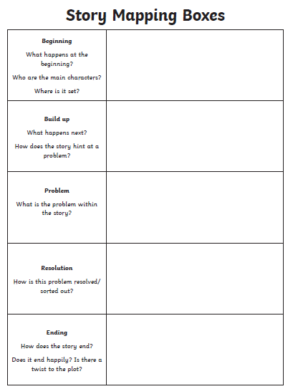

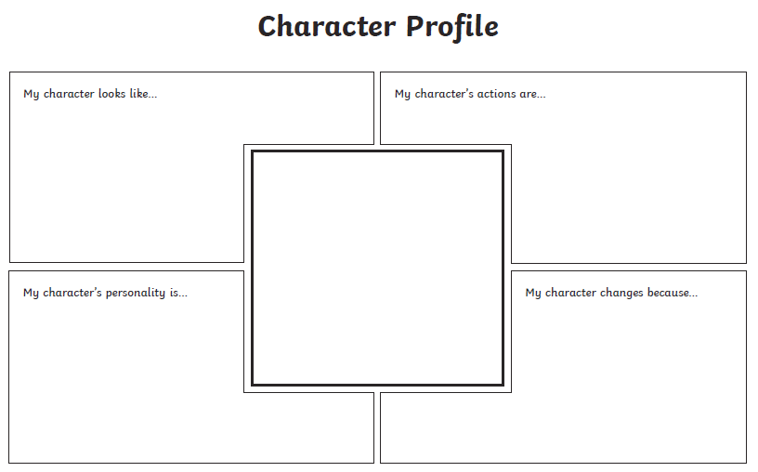

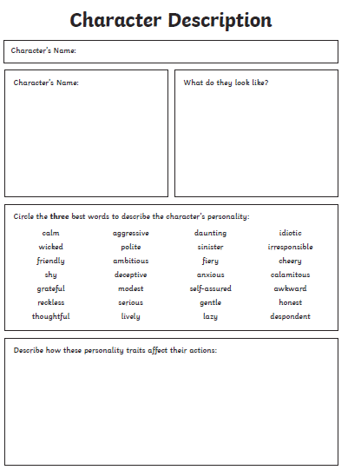

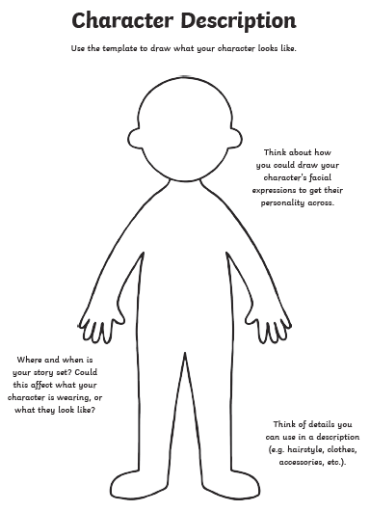

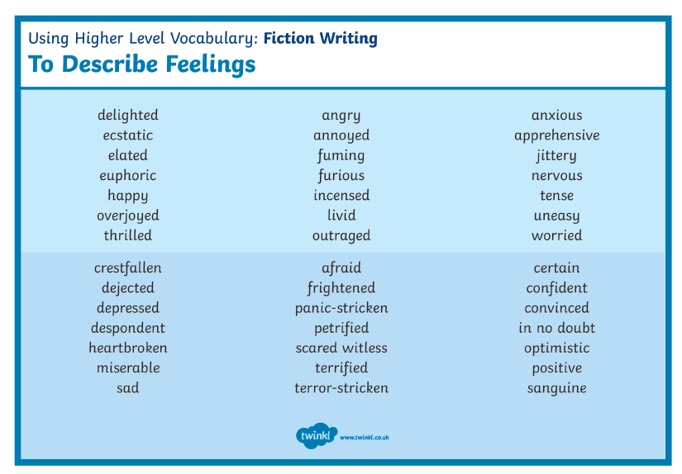
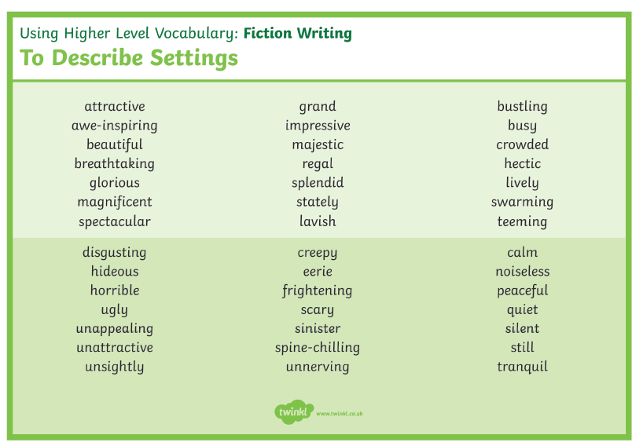
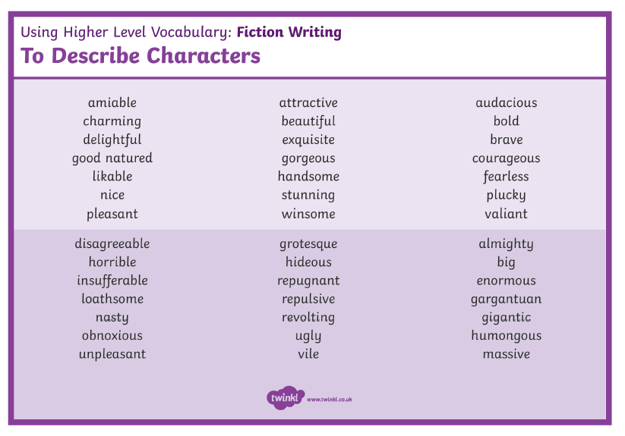
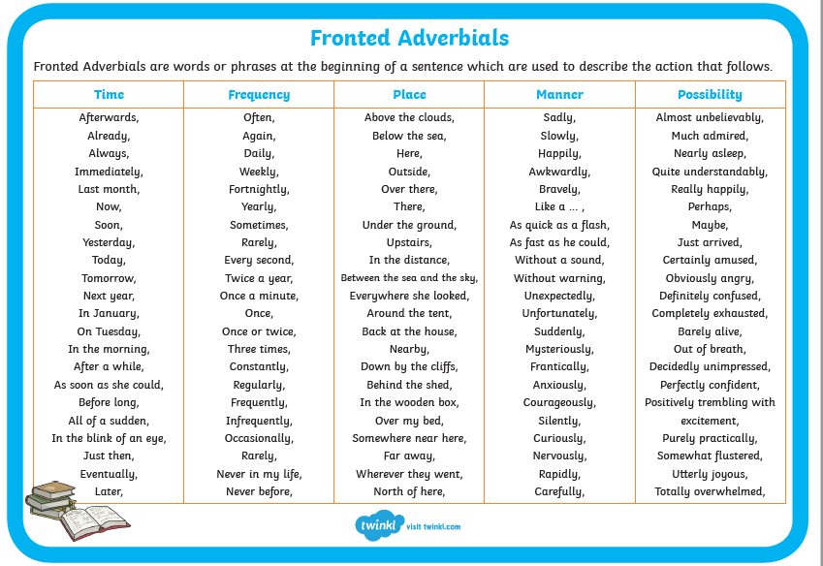

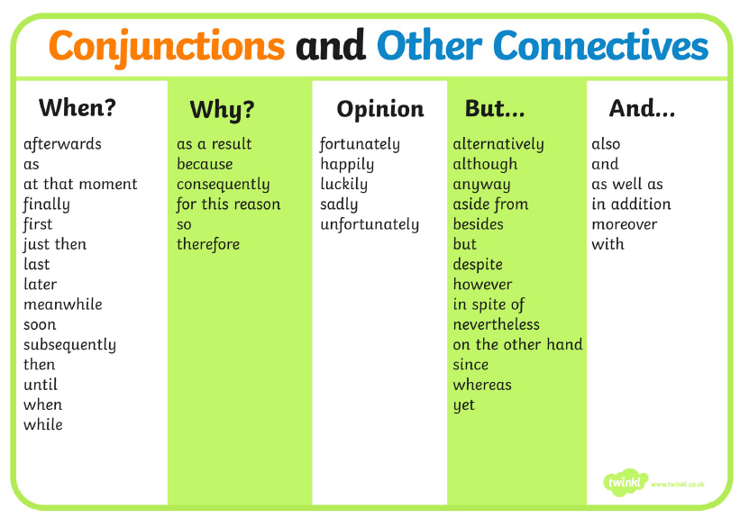
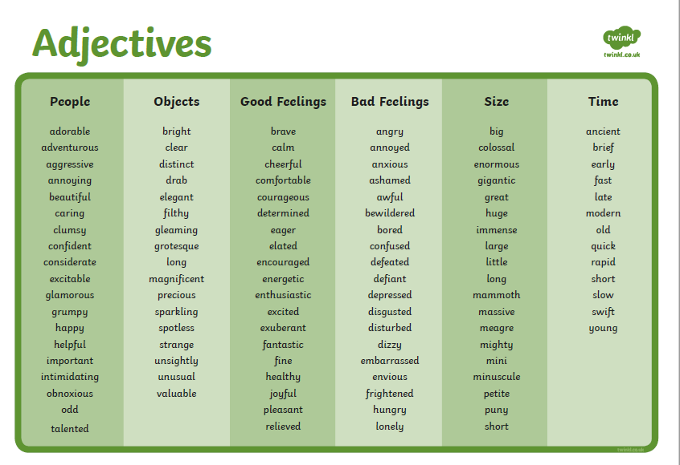

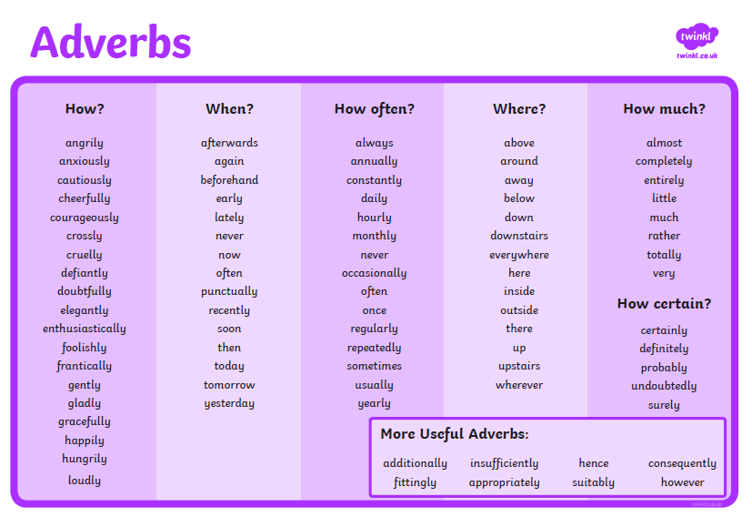
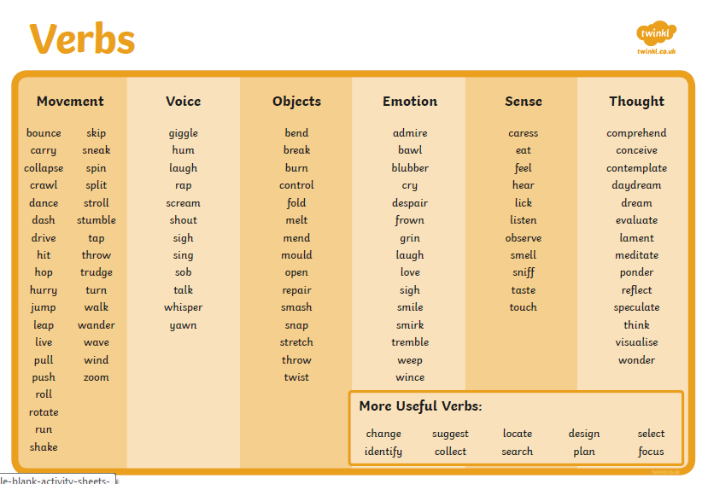
Maths:

All Videos and Worksheets available at:
You can work through the resources for Fractions this week. Just do 1 per day this time!
Year 5 : https://whiterosemaths.com/homelearning/year-5/
Make sure to find the corresponding video. The worksheets are with the videos or have in the same order as the videos.

You can work through the resources for Fractions, Decimals and Percentages this week. Just do 1 per day this time!
Year 6: https://whiterosemaths.com/homelearning/year-6/
Make sure to find the corresponding video. The worksheets are in the same order as the videos.

Science – All the corresponding resources are on the Home Learning Resources Tab on the Beech class web page already.

Extras for this week: Using google maps, your imagination or a place from a story you have read, can you have a go at drawing an Ordinance Survey Map of that area? Read through all the resources that we have provided before having a go!
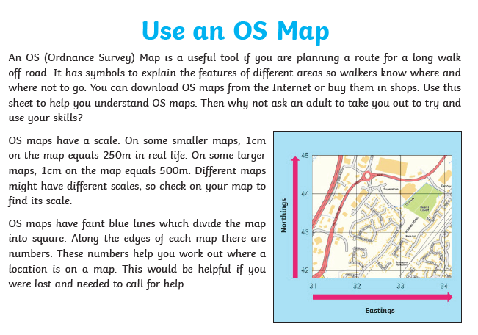

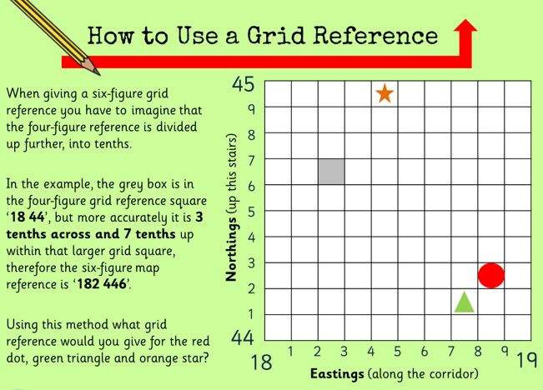
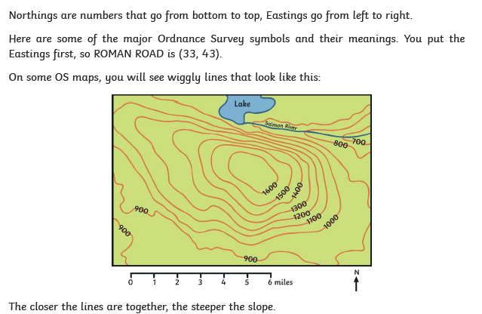

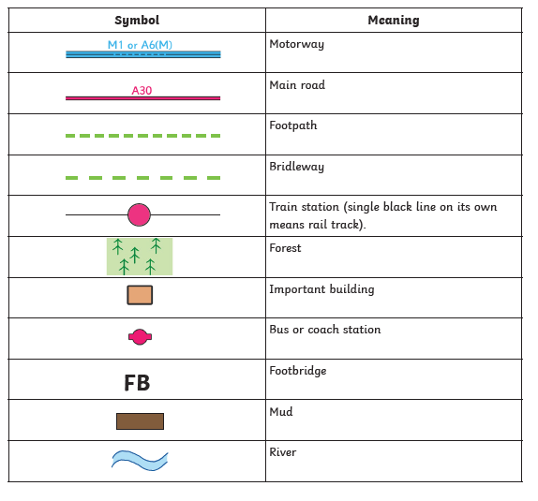

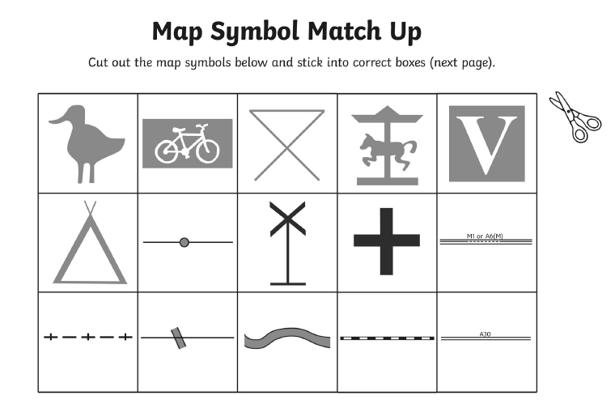
What do you think all these symbols could represent? The answers are on the next sheet; did you get them all right?

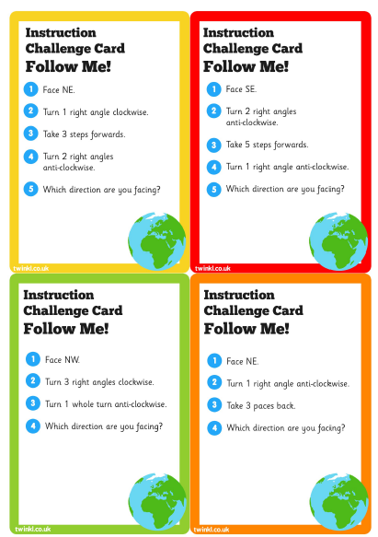

Here are some challenge cards to practice your directions!
https://www.bbc.co.uk/teach/class-clips-video/using-a-compass-and-reading-maps/z77tf4j

Follow this link to look at the different points on a compass.

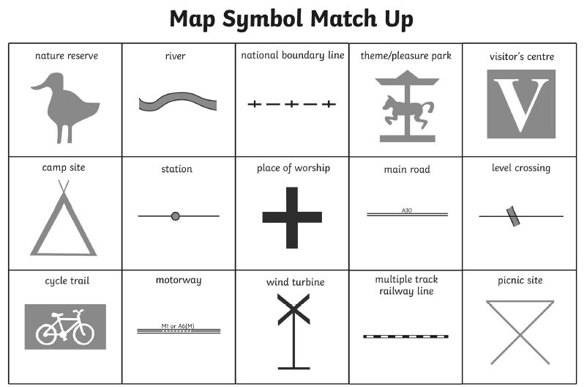
MAP CHALLENGES YOU COULD HAVE A GO AT FIRST:
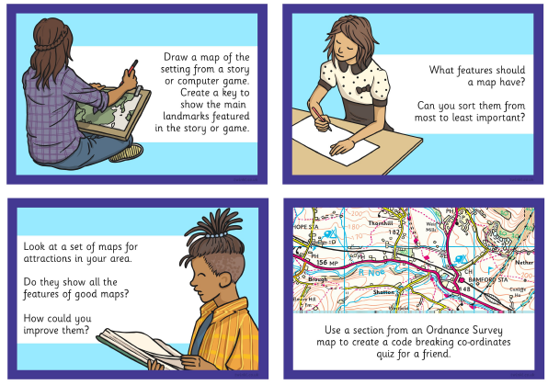
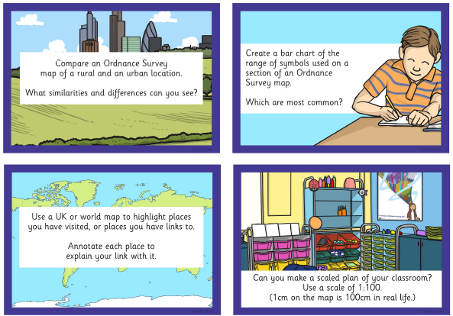

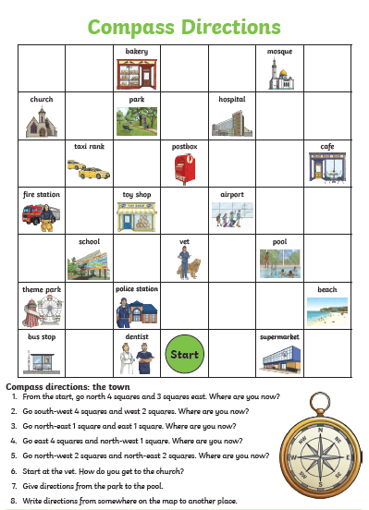

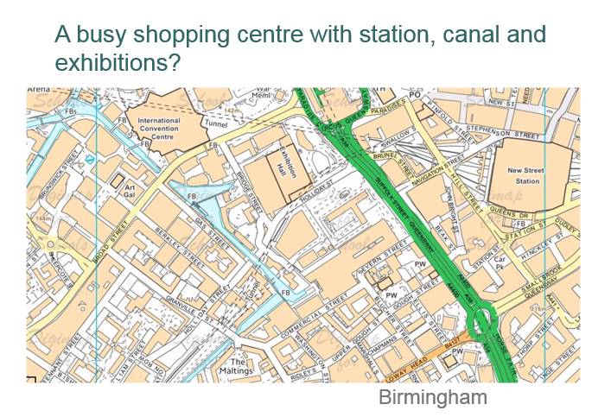
Fantasy Maps:
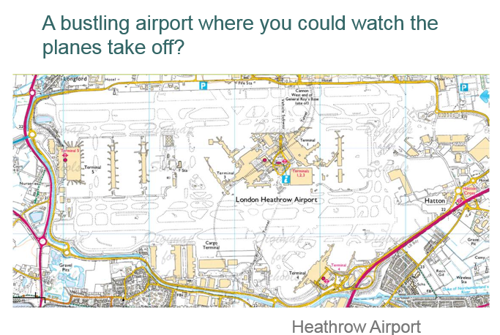
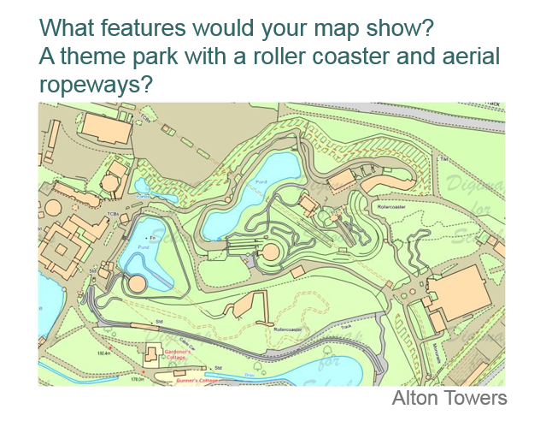
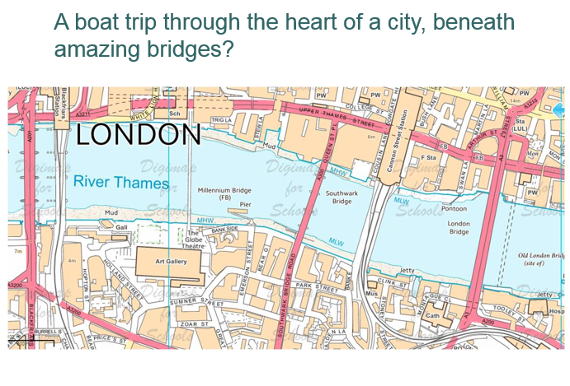
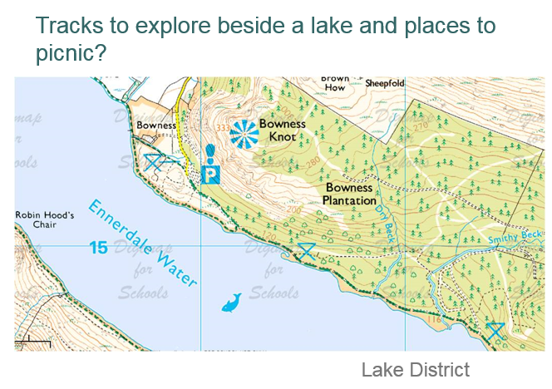
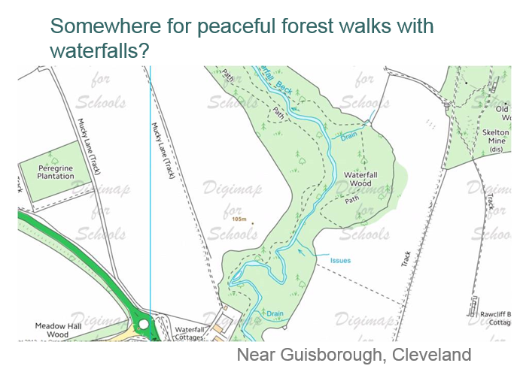
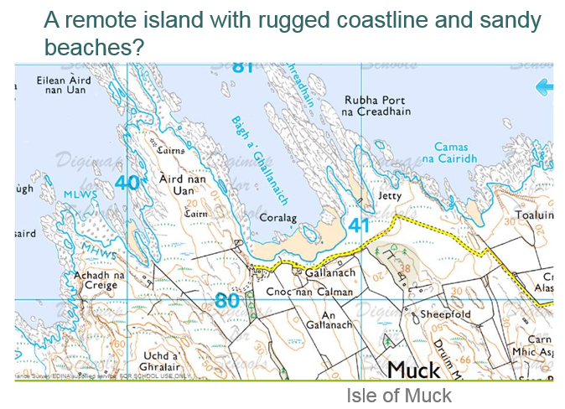
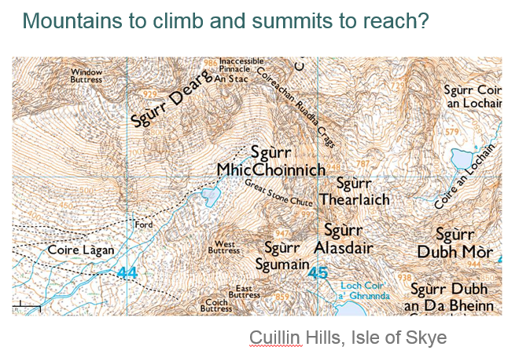
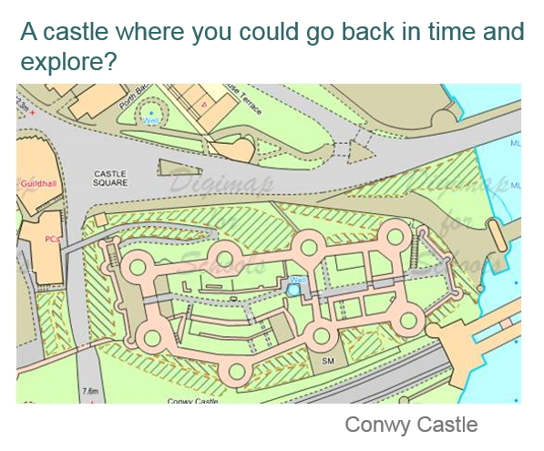
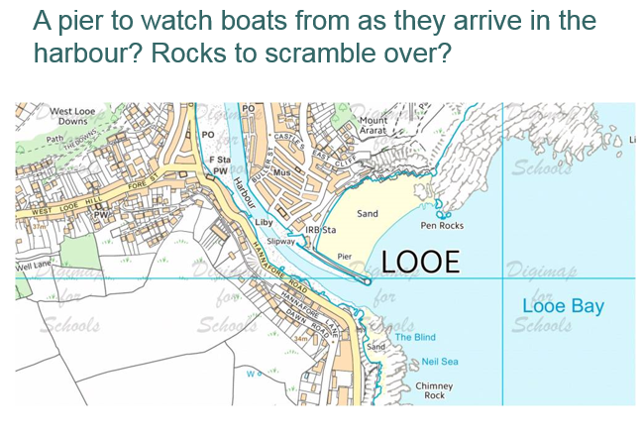
Looking at the different features of the maps you have seen, can you now have a go at designing your own for a small area?

