Week 1 Resources:
If you are unable to print out the resources, you can do your activities and planning in your blank exercise book.

Poetry: Write a poem about what you can see from your window
(Remember our Sound, Colour, Emotion and Movement structure)
(Or OSIE – Observe, Senses, Imagination and Emotion)
Use this sheet as a planning resource for words you can think of when you look out your window. You can use an online dictionary or thesaurus to help you uplevel your language.
Then add figurative language: metaphors, alliteration, similes, personification, onomatopoeia, hyperbole and idioms if you want to challenge yourself!
SOUND | COLOUR
EMOTION | MOVEMENT
OBSERVE | SENSES
EMOTION | IMAGINATION

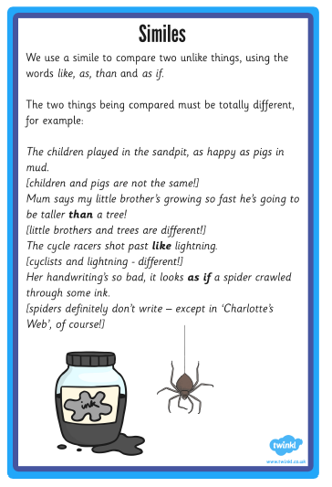
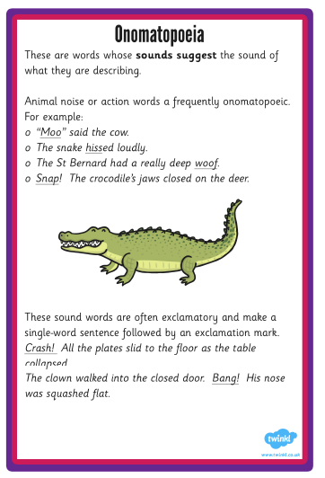
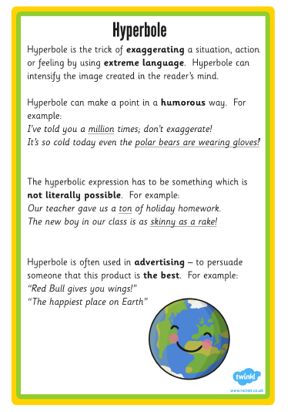
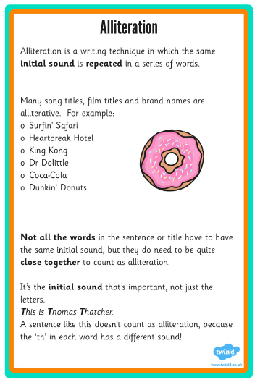

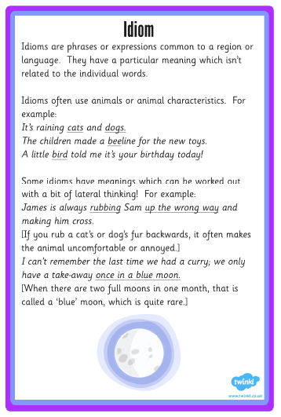
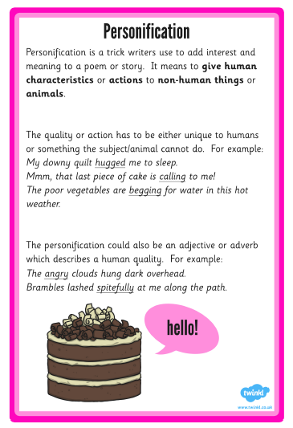

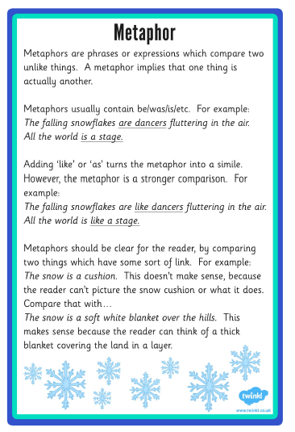

Poem: At least 2 verses, but you can write as many as you would like:

Title:________________________________________________________

S:_______________________________________________________________________________
C: _______________________________________________________________________________
E: _______________________________________________________________________________
M: _______________________________________________________________________________

S:_______________________________________________________________________________
C: _______________________________________________________________________________
E: _______________________________________________________________________________
M: _______________________________________________________________________________

S:_______________________________________________________________________________
C: _______________________________________________________________________________
E: _______________________________________________________________________________
M: _______________________________________________________________________________

S:_______________________________________________________________________________
C: _______________________________________________________________________________
E: _______________________________________________________________________________
M: _______________________________________________________________________________

S:_______________________________________________________________________________
C: _______________________________________________________________________________
E: _______________________________________________________________________________
M: _______________________________________________________________________________

Maths:

All Videos and Worksheets available at :
For the next 2 weeks, you can work through the 4 weeks of fractions, decimals and percentages activities (2 per day)
Year 5 : https://whiterosemaths.com/homelearning/year-5/
Make sure to find the corresponding video. The worksheets are in the same order as the videos.

For the next 2 weeks you can work through the 4 weeks of ratio and angles resources (2 per day)
Year 6: https://whiterosemaths.com/homelearning/year-6/
Make sure to find the corresponding video. The worksheets are in the same order as the videos.

Science – All the corresponding resources are on the Home Learning Resources Tab on the Beech class web page already.

Extras for this week: Design a birthday cake for the Queen. You can do this on blank paper or in your exercise book.

